“SUSPICIOUS MINDS”
A FILM BY CHRISTOPHER HENSEL
And TODD MATTHEWS
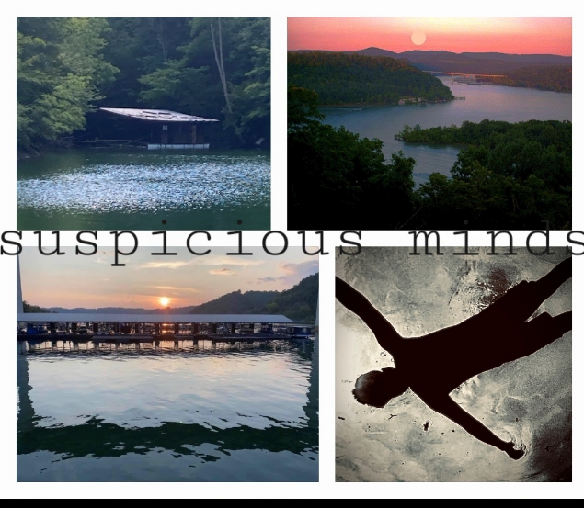

SUSPICIOUS MINDS

LOGLINE:

What do you get when you cross an eccentric, backwoods, moonshining family (many of questionable character) with a deceased patriarch’s final wishes? As the crazy relatives of the Lawhorn family vie for a piece of Big Daddy’s fortune, family secrets that have been buried for generations reveal themselves, causing a myriad of mysterious phenomenon to occur. When family is no longer who you can depend on … who can you trust?

The small town of Livingston, TN is turned upside-down as potential heirs bombard the houseboat to claim what they believe is rightfully theirs. Things go from bad to down-right ugly when it’s announced the old man threw a twist in his will. His four sons to his first wife get absolutely nothing. His treasured daughter Lauren inherits everything, however, she is also charged with caring for her reprobate sister, Ginger.

Family secrets that have been buried for generations and incredulous alliances create a backdrop for this suspenseful-murder/mystery/love story. Lauren’s husband TJ carries the biggest secret of all, but can their marriage survive as everything begins to unravel?

Producer/Writer/Director Christopher Hensel, Jeb Stuart Duke of the Dukes of Hazzard, and Writer/Producer Todd Matthews and are looking for Private Individuals, Company Sponsorship - Family Businesses that would love to be involved in one of the biggest independent movie genres today: Murder/Suspense/Thriller Films.

