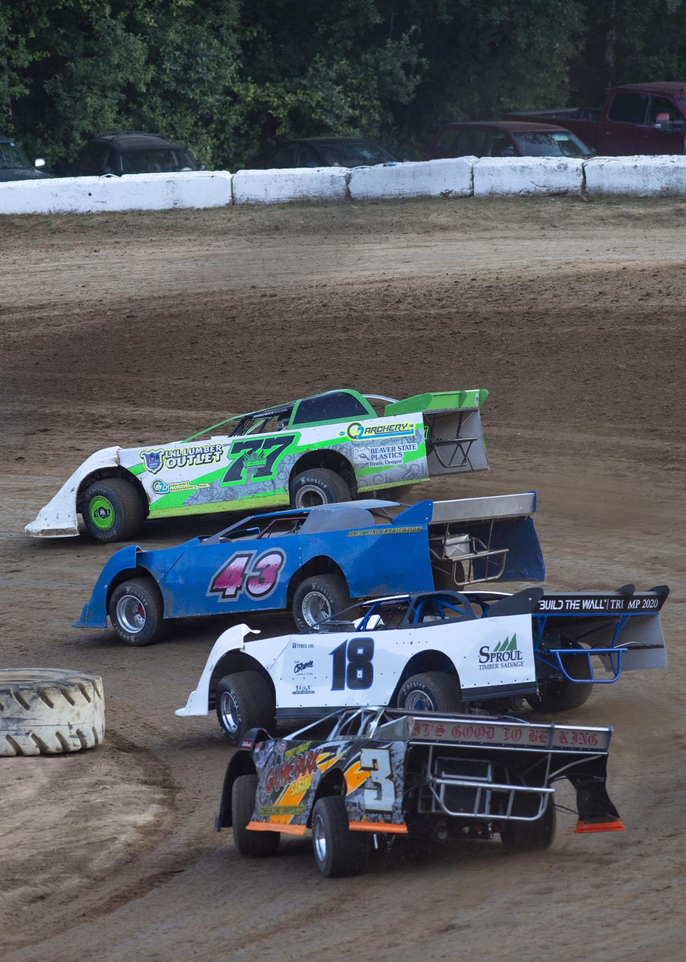
“RACE FOR REDMPTION”
FORGIVE YOURSELF AS YOU SEEK REDEMPTION

A REAL DUKES OF HAZZARD STYLE
CAR RACING, CAR CHASING, STUNT FILLED
GOOD VERSUS EVIL, COUNTRY MUSIC
FUN LOVING FAMILY FILM SERIES

NO SEX, NO SWEARING, NO NUDITY, NO KIDDING! GOOD OLD FAMILY FUN!
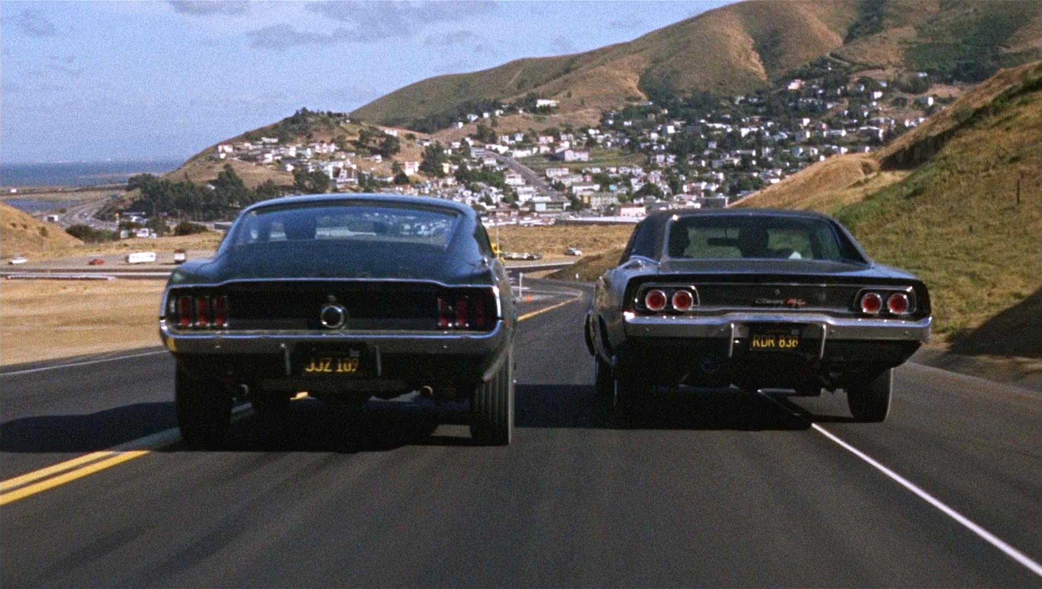

Race for Redemption
A GOOD OL’ BOYS CAR RACING CAR CHASING MOONSHINING COUNTRY MUSIC STYLE FAMILY FILM
Logline: Forgive yourself as you seek redemption
STORY: An old moonshining codger has died, and the family farm is headed for foreclosure. The last remaining relative (a drunken nephew still pining over the loss of his son which is why he left the farm in the first place) has been notified and has returned to see if he can save his old family farm from being taken over by the enemy under the disguise of back taxes. He enlists the help of his daughter, grandson and niece. Can an old dusty race car and a dirt track save them from the greedy, underhanded, shenanigans of Big Momma & her cronies that originally caused the problems in the first place? Action packed/stunt filled/country music filled fun loving family film series.

